This document is for CSC 500 Module 4 Portfolio Milestone Online Shopping Cart, including step1, step2 and step3 python code, screenshots of the application executing the code and the results on pycharm, python file Github link, challenges and experience of this assignments.

**Step 1:** Build the ItemToPurchase class with the following specifications:

* Attributes
* item_name (string)
* item_price (float)
* item_quantity (int)
* Default constructor
* Initializes item's name = "none", item's price = 0, item's quantity = 0
* Method
* print_item_cost()

**Example of print_item_cost() output:**Bottled Water 10 @ $1 = $10

**Python script:**

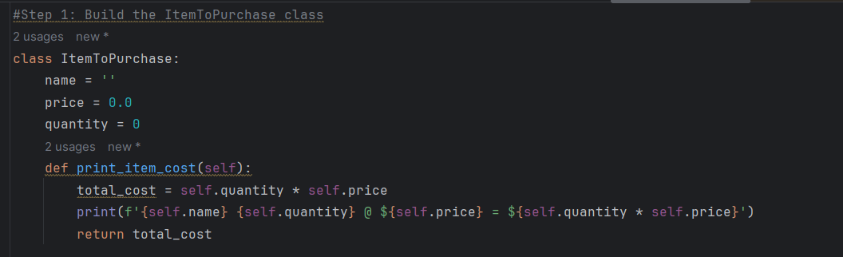

**Step 2:** In the main section of your code, prompt the user for two items and create two objects of the ItemToPurchase class.

**Example:**

Item 1

Enter the item name:

Chocolate Chips

Enter the item price:

3

Enter the item quantity:

1

Item 2

Enter the item name:

Bottled Water

Enter the item price:

1

Enter the item quantity:

10

**Python script:**

Step 3: Add the costs of the two items together and output the total cost.

**Example:**

TOTAL COST

Chocolate Chips 1 @ $3 = $3

Bottled Water 10 @ $1 = $10

**Total: $13**

**Python script:**

**Step 1 to Step 3 python code executed on pycharm:**

**Python script .py file in Githup:** [CSC500-Module-3-assignment/Module3.py at main · lzadams/CSC500-Module-3-assignment (github.com)](https://github.com/lzadams/CSC500-Module-3-assignment/blob/main/Module3.py)

**Challenge and experience:**

Step 1 and step 2, it is easier to create a class and define 2 items following instructions in the reference.

Step 3 was challenging, which took me more than half an hour to figure out, because I did not define total_cost in the step 1 and ‘total_cost = item1_cost + item2_cost’ did not work.

**Reference:**

[Python Classes and Objects (With Examples) (programiz.com)](https://www.programiz.com/python-programming/class)